Student’s Name
Professor’s Name
Course Number
Date
Project Initiation and Payback Analysis
Project Name | AUTOMATED VEHICLE TECHNOLOGY PROJECT
Date | September 13,2018

Product Description
Vehicle automation is an important solution to the upcoming and existing challenges in the transport industry. Most of vehicle crashes are caused by human error and these problems can be mitigated through the application of automation. Vehicle automation project will enhance mobility, roadway safety and freight movement.
Vision
To deliver efficient, safe and reliable transportation system through the establishment of a vehicle automation driving environment. This will include the key focus on sectors like vehicle to vehicle communications, freight logistics, advanced mobility technological applications, as well as integrated flow of services and data
Project Objectives
The objectives for this project are established to create a conducive environment in which the advanced technologies and automated driving can thrive in our roads. The objectives are:
- Establish new capacities which will help the people to drive efficiently and move the goods more effectively than today.
- To make our company a leader providing a conducive environment for automated driving products.
- Facilitate automated driving services in all the sectors of the economy
Project Requirements
- Cloud Platform which ingests vehicle data sensor and infrastructure to enhance the distribution of alerts
- Software for initial application to assist in incoming data processing , generate efficient alerts, transmit ,direct and display them for vehicles ,as well the human driver

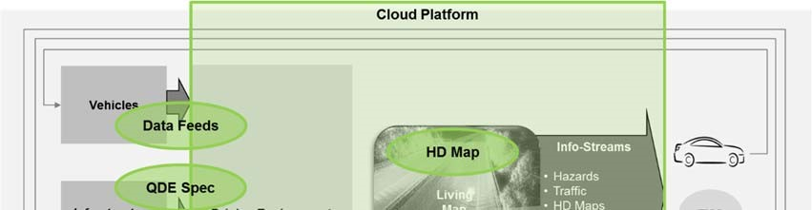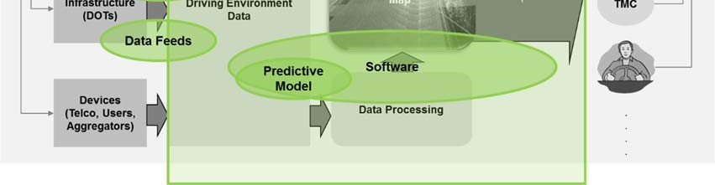

Figure A: Communication overlay software

Project Deliverables
Automated vehicles systems in profession fleets, transit, and freight .Transit buses transporting people, goods and services operating in controlled access area like international airport will be automated. Profession fleet vehicles such taxis will be fitted with automation technology to enhance easy monitoring through the development of software application to improve communication between the drivers and the customers.
Project Constraints
The project requires multi-partner, multi-year, and complex effort to achieve the vision, goals and objectives of the company. The project requires huge financial, physical, time, technological and human resources to be completed.
Project Assumptions
- When crash is detected by the automated system, it will send the information to the drivers, alerting them to change the lanes, exit or slowdown.
- During hazardous road conditions or extreme weather scenarios the driver will receive a message such as adverse weather condition or the black ice on road to help the driver to avoid the area or slowdown
- The system will notify the drivers of the specific timing and places where construction work is done to avoid unsafe situations along the routes of work.
- During special days as national holidays or function the drivers will be notified of real‐time situations and queues, enabling them to changes routes where necessary

Stakeholders Analysis
Project Stakeholder | Description
Contract Management | Position: Responsible for the creation of the SOW, review negotiations, and proposals.  Attitude: Neutral  Influence: High
Customers | Position: business, and homeowners within the country where our company operates. The clients will be required to install the automotive vehicle application in their phones  Attitude: Neutral  Influence: Low
Project Manager | Position: Developing attainable and achievable project objectives, building requirements of the project, and managing the project constraints  Attitude: positive  Influence: High
Project Sponsor | Position: This is the person with overall accountability for the requirements of the project  Attitude: Positive  Influence: High
Suppliers | Position: These are the individuals the provide materials services the firm uses on daily that require integration into the vehicle automation software system.  Attitude: Neutral  Influence: Low
Project Team | Position: This is comprised of persons from different departments of the firm who have been assigned specific activities and tasks as part of the whole project.  Attitude: Positive  Influence: Low

Cost Benefit Analysis
Budget
 | Year 1 Cost | Year2 Cost | Total
Taxi | $4 million | $4 million | $8 million
Bus | $ 6 million | $ 6 million | $ 12 million
Lorry | $ 7 million | $ 7 million | $14 million
TOTAL | $17 million | $ 17million | $ 34 million

